***Click any picture for a link of one possible location to purchase the item***

Lab 01 - Metric System
Student Provides | 3 | Heat Resistant Coffee cups
 | 1 | Ice cubes
 | 1 | Marble or similar object
 | 1 | Meter stick
 | 1 | Pen
 | 1 | Sugar or salt
 | 1 | Water, tap (and ice cubes)
 | 1 | Pipet (something like this >> 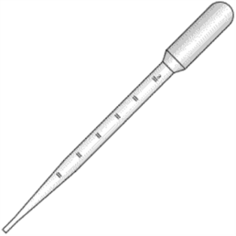 - pics are linked to possible places to purchase – you will need more than one through the semester)
 | 1 | Graduated cylinder (like this >>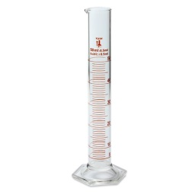 or this 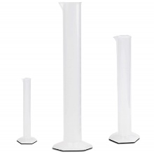 both pics are linked to possible places to purchase these items.)
 | 1 | Thermometer
 | 1 | Scale– must measure in grams
 | 1 | Beaker or 1 cup measuring cup (like this> 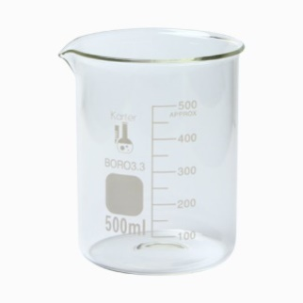 pic is linked to one possible place to purchase)  **the link is to a 500mL beaker. You need 250mL or larger. This just was the best price.
 | 1 | Piece of paper to cover scale top

Lab 02 - Water / pH
Student provides | 1 | Cup, measuring (1 cup size)
 | 2 | Needle or straight pin
 | 2 | Paper Towels
 | 2 | Needle or straight pin
 | 2 | Cup or drinking glass, 2 oz.–8 oz., flat top
 | 50 - 100 | Paper clips
 | 1 | Coin (Penny, nickel, dime, or quarter)
 | 1 | Water, tap
 | 10 | Pipets
 | 1 | Celery stalk with leaves or white carnation flower
 | 1 | Cutting board
 | 1 | Knife
 | 1 | Food Coloring
 | 1 | Drinking glass or vase
 | 1 | Ruler, metric
 | 1 | Cabbage, red, 1 cup
 | 1 | Stove & pot, microwave, or tea-kettle (to boil water)
 | 1 | Bowl, heat-safe, 2.5-cup capacity or larger
 | 1 | Spoon
 | 1 | Scissors
 | 2 | Coffee Filters
 | 1 | Safety Glasses
 | 1 | Gloves (vinyl or nitrile --- gloves to protect your hands from chemicals)
 | 9 | Household items to test pH: for example—lemon juice, vinegar, soda, milk, coffee, orange juice, shampoo, rainwater, soap, cleaning products

Lab 03 - Mitosis

N/A – on computer

Lab 04 - Histology

N/A – on computer

Lab 05 – Anatomy of Skeletal System

N/A – on computer

Lab 06 - Anatomy of Muscular System
Student provides | 1 | Partner or family member to assist you
 | 1 | Human Biology textbook or other large book

Lab 07 – Selected Special Senses
Student Provides | 10 | Household items with various odors (could be apples, lemons, cherry soda, etc)
Student Provides | 1 | Plastic cup (or similar item) to hold various combinations of liquids and solids
Student Provides | 1 | paperclip or cork with two pins
Student Provides | 1 | Partner to work on experiment

Lab 08 - Blood

N/A – on computer

Lab 09 - Heart Physiology
Student Provides | 1 | Human Biology Textbook for reference
 | 1 | A partner or family member to perform some of the activities
 | 1 | Access to a grocery store/pharmacy automatic blood pressure monitor
 | 1 | Stopwatch (digital) or phone to keep track of time

Lab 10 - Respiration
Student Provides | 1 | Timer or clock
 | 1 | An assistant
 | 1 | Metric ruler
 | 1 | Approximately 60 cm length of vinyl tubing (basically enough to get from inside the container to the straw) 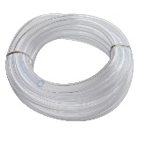 (You may want to know the size of your straw first so you know what the inner diameter (I.D.) should be so the straw will fit)
 | 2 | Drinking Straw
 | 1 | 3.8 liter (1 gallon) clear plastic jug
 | 1 | 250 ml measuring cup
 | 1 | pail for water
 | 1 | masking tape
 | 1 | marking pen
 | 1 | plastic tub (or can use a sink if it can be stoppered)
 | 1 | Funnel
 | 1 | food coloring (optional)
 | 1 | Dropper
 | 1 | Sponge

Lab 11 - Chemoreceptors
Student Provides | 1 | An assistant
 | 1 | Fresh apple, potato and onion
 | 3 | Sealable containers
 | 1 | Blindfold scarf or fabric
 | 1 | Toothpicks

Lab 12 – Urinalysis
Student provides | 15 | Urinalysis Test Strip – must be 10 parameter or more ( like this>> is a 100 count >> 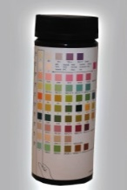 pics are linked to possible places to purchase)
 | 1 | Beaker (like this>> 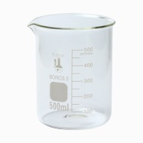 pic is linked to one possible place to purchase)  **the link is to a 500mL beaker. You need 250mL or larger. This just was the best price.
 | 1 | Salted pretzels
 | 1 | Distilled water
 | 1 | Caffeine based drink
 | 1 | Timer or clock

